Welcome to the Rogers Airman Leadership School Class 22-4



**Congratulations!!!**

Welcome to the Rogers Airman Leadership School (ALS). ALS is your first experience with Professional Military Education, a milestone in your Air Force career. This course will challenge you to discover the duties, responsibilities, and skills you must practice to become a successful Air Force supervisor and leader.

The ALS curriculum is rigorous. You will need to mentally prepare yourself and your family for the increased workload over the next five and a half weeks. You will have reading and homework assignments that will be completed outside of the duty day.

We look forward to meeting you. Feel free to call or visit the school so we may address any concerns or questions you might have about the course. Please contact us at 925-1233 for assistance.

Address:

Rogers Airman Leadership School

1000 Mercury, Bldg 100

Chapman Training Annex, TX 78236

(210) 925-1233

Map Coordinates: 29.373668, -98.651771

***Class Start Date****: 15 April 2022*

***Start Time****: 0730*

***Uniform:*** *OCP*

***Graduation Date:*** *18 May 2022*

**What to Expect...**

**Uniform**

The uniforms you wear must be neat, clean, safe, serviceable, show proper military image, and IAW AFI 36-2903 guidelines. Uniform considerations:



•  There will be scheduled and no notice inspections, be prepared and have all uniforms ready.

* The following uniform items will be required during the course: **OCPs and official Air Force PT gear.** Also, you will be required to have a white semi-formal shirt or mess dress uniform to wear for graduation.
* We have (optional) business casual days to provide an opportunity to practice the appropriate attire for a professional environment outside of the uniform.

•  Reveille, and Retreat will be conducted outdoors throughout the course.

•  No organizational or functional items (organizational hat/MTI Campaign hats) will be worn, with the exception of the Security Forces/Special Forces berets.

**Physical Training**



* PT will be conducted as a class 2-3 times a week. You are required to wear the official Air Force PT gear. The Rogers ALS adheres to both AFI 36-2903 and JBSA PT gear guidelines.
* At the end of the course you will participate in a class ruck march. The uniform will be tactical gear, not PT gear.
  + Boots or hiking/PT shoes (encouraged)
  + Any combat/tactical issued trousers (ex: OCPs/ABUs)
  + T-shirt (ex: sand/moral shirt)
  + Blouse is optional (if worn, must have appropriate rank)
  + Cover is optional too. May wear a booney hat, cover, or hat with military affiliate patch
  + The ruck must be no more than 20 lbs

**Profiles & Waivers**

* If you are on a profile/waiver, please let your flight room instructor know. It must also state you can do PT at your own pace.



**What do I need to know before class starts??**

* **Appointments: Please have a complete list of dates and times of appointments that may occur during ALS. You will provide this information to your primary instructor on DOE 1, at their discretion or based on course work that day, some appointments may have to be rescheduled or canceled. If further information is required please contact the school house at (210) 925-1233.**
* **Hours:** Normal class hours are from 0745 to 1545. Lunch is scheduled from 1115 to 1215. Reveille and Retreat will be conducted IAW the class schedule. In addition, plan on participating in a class community involvement project.
* **PT sessions** will start at 0700 so please plan accordingly.
* **Mission Statements**: Students must have their Squadron, Group and Wing (or equivalent) Mission statements with them and be familiar with how they interact and support said mission’s statements.
* **Contact numbers: Cell phone usage during the duty hours is prohibited and cell phones are not allowed in the flight rooms.** Instead,all routine (non-emergency) calls from office or family will be directed to 925-1233 to leave messages.
* **Graduation:** Graduation will be a formal evening event at the Gateway Club. The cost per person is $27 for non-club members and $25 for club members. Students will be required to invite their commander (or delegated representative) and will also be allowed to bring one personal guest of their choosing.
* **Items Needed for 1st day of class:**
  + Personnel Locator Sheet
  + Signed Student Responsibilities Memorandum
  + 1st Sergeants Name and Cell Phone Number
  + Proof of COVID vaccination (if applicable)
  + All student material will be issued electronically. Please bring a laptop, tablet, or any electronic reader that has ability to operate firefox software to access LMS Canvas platform. The devices must be able to utilize power point/slide capability. **Cell phones will not be used to store lesson material**. If needed, please coordinate with your unit to see if they can provide you one.
* **Parking**: Student parking is located on the west side of the building ONLY, near the tennis courts. There is no parking in front of the school house for students.

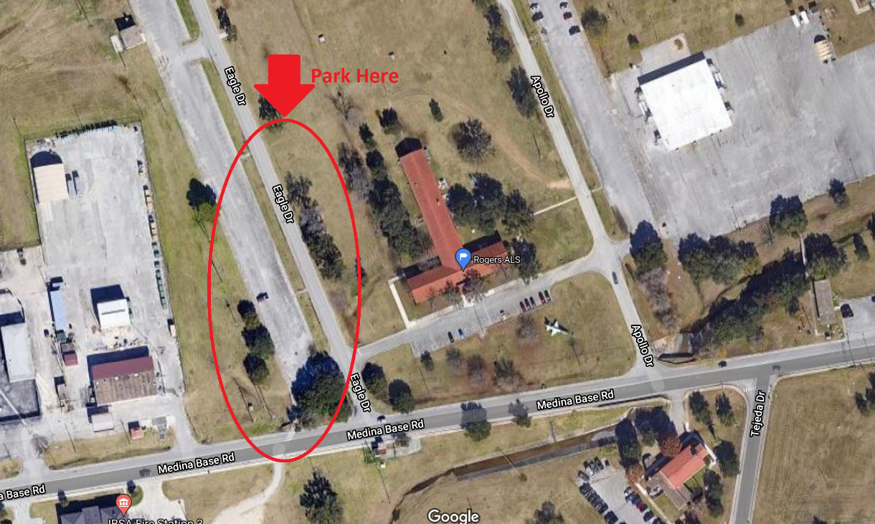

**Volunteer Event**

During your time at ALS, you as a class will be participating with a volunteer project. The project will be on the first weekend April 23rd 2022 from 0730-1200 and location TBD. Please ensure you plan accordingly to be present.